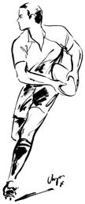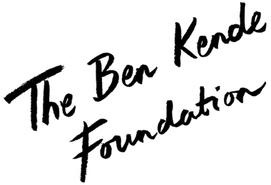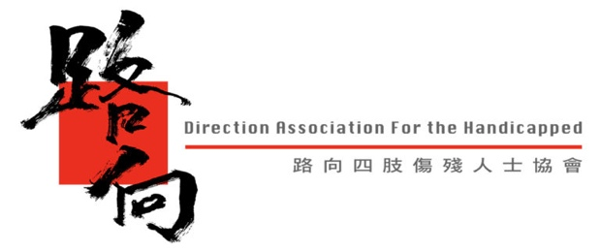

HK Club’s Gareth Williams invites you to join us for

The Ben Kende Foundation and Direction Association for the Handicapped

BLACK AND WHITE SPINAL CURE DINNER

Raising awareness and finding a cure for paralysis

Featuring guest speaker Peter Robinson
Peter Robinson is a record-breaking trans-Atlantic rower and all-round adventurer. Peter was one of the Four Oarsmen who hold the world record for the fastest team to row across the Atlantic. To add to his collection of inspiring feats, Peter has recently completed a fully unsupported 570km expedition across Greenland.

Including:
Four-course dinner
Free flowing wine and beer
Silent auction
Showcase of the ReWalk Exoskeleton
… and more!

Date: Saturday, 28th September 2019
Time: 8pm – midnight
Venue: The Hong Kong Club – First Floor
Dress Code: Black and White Cocktail

GOLD SPONSOR TABLES
HK$29,000
Tables of 11
Gold sponsors will gain a full page advertisement in the event programme given to each guest, a prime seating position at the Hong Kong Club, as well as marketing materials and signage displayed at the event.

SILVER TABLES
HK$13,750
Tables of 11 at HK$1,250 per seat

INDIVIDUALS AND SMALL GROUPS
HK$1,250 per person
Assigned to tables

IF YOU WOULD LIKE TO BOOK ANY OF THE OPTIONS ABOVE, PLEASE FILL OUT THE FORM OVERLEAF AND EMAIL IT TO EITHER YOUR TABLE HOST OR BKFHONGKONG@GMAIL.COM

Where funds will go:
Despite being closer to a cure for paralysis than ever before, a lot of progress is still to be made. We will be sponsoring a research project into epidural stimulation – currently the closest thing to a cure, with extremely promising results – in the hope that goal can be reached a little bit sooner.

BOOKING FORM

NAME:
COMPANY:
ADDRESS:
CONTACT: | TELEPHONE | ________________ | EMAIL |  | __________________________________
TABLE HOST (if applicable):

I will make payment of HK$___________________________ by the following method:
- Bank Transfer
- Cheque
- Other:

Signature: |  | Date:
Name:

PLEASE SEND YOUR COMPLETED FORM EMAIL TO EITHER:
- your table host identified in the form above; or
- bkfhongkong@gmail.com

Once we have received your booking form, a booking confirmation will be sent to the email address provided in the form above, along with an invoice issued to the name provided in the form above.

For further information please contact either your table host, bkfhongkong@gmail.com or Jenny Kende at +852 90412199

